

**DEVFORGE - TECHNICAL QUIZ PLATFORM**

**A PROJECT REPORT**

**SUBMITTED BY**

**BRINDHA.S(61781921110044)**

**SOWNDHAR KRISHNAN.R(61781921110054)**

**VAISHNAVIY.S(61781921110059)**

**SAHANA.V(61781921110044)**



**TABLE OF CONTENTS**

CHAPTER NO TITLE PAGE NO

ABSTRACTION 3

1. Problem Statement 4

2. Introduction 5

3. Project Description 6

4. Technical Specifications 7

5. Uniqueness 8

6. Use Case Diagram 9

**APPENDIX 1 SAMPLE CODE**

**APPENDIX 2 SAMPLE SCREEN SHOTS**

**ABSTRACT:**

Devforge is a groundbreaking online platform designed to cater to the insatiable thirst for knowledge among tech enthusiasts. It offers a comprehensive array of quizzes and assessments covering a wide spectrum of technical topics, from web development to operating systems and computer networks. What sets Devforge apart is its innovative approach to learning, integrating gamification elements such as point systems and streak tracking to motivate users towards consistent engagement. By fostering a vibrant community of learners and providing personalized learning experiences, Devforge aims to revolutionize the way individuals approach technical education.

**Problem Statement:**

In the realm of technology education, the existing landscape often falls short in providing learners with engaging and personalized experiences. Traditional methods struggle to sustain motivation, leading to disengagement among learners. Additionally, educational institutions face challenges in modernizing assessment practices to meet the dynamic needs of students and align with evolving curricula. There is a critical need for an innovative online platform that not only offers personalized assessments but also integrates gamification elements to inspire consistent participation and foster a sense of accomplishment. This project aims to address these challenges by developing Devforge, an advanced online assessment platform designed to revolutionize technology education and empower learners to succeed.

**Introduction:**

In today's rapidly evolving technological landscape, the need for continuous learning has never been more critical. Devforge emerges as a beacon of innovation in the realm of online education, specifically tailored for individuals passionate about technology. It seeks to address the challenges faced by learners in staying motivated and engaged over time by infusing elements of gamification and community interaction into the learning process. Through Devforge, users embark on a journey of self-improvement, guided by their curiosity and fueled by the platform's dynamic features.

**Project Description:**

Devforge represents a paradigm shift in online education, offering a multifaceted platform designed to empower tech enthusiasts in their quest for knowledge. At its core, Devforge houses an extensive repository of quizzes and assessments spanning various technical domains, meticulously curated to cater to users of all skill levels. What sets Devforge apart is its emphasis on engagement and motivation. Users earn points for their participation, with streak tracking rewarding consistent engagement. This gamified approach not only incentivizes learning but also fosters a sense of accomplishment and progression. Moreover, Devforge serves as more than just a learning platform; it cultivates a vibrant community where users can connect, collaborate, and share insights, enriching the learning experience manifold.

**Technical Specification:**

**Frontend:** Devforge leverages React.js, a cutting-edge frontend library renowned for its component-based architecture and seamless user experience. Through intuitive interfaces and interactive elements, users navigate the platform effortlessly, immersing themselves in a rich learning environment.

**Backend:** Powered by Node.js and Express.js, Devforge boasts a robust backend infrastructure capable of handling concurrent requests and managing data efficiently. MongoDB serves as the database of choice, offering scalability and flexibility to accommodate the platform's growing user base and evolving needs.

**Uniqueness:**

Devforge stands out in the realm of online assessment platforms due to its innovative approach to learning and engagement. Its key differentiators include:

* **Personalized Learning:** Tailored quizzes and assessments cater to individual interests and skill levels, providing a customized learning experience.
* **Gamification:** Integration of point systems and streak tracking motivates users towards consistent engagement and fosters a sense of achievement.
* **Community Interaction:** Vibrant community features encourage collaboration, knowledge sharing, and peer-to-peer support, enriching the learning journey.
* **Scalability:** Built on the robust MERN stack and utilizing MongoDB for flexible data storage, Devforge is equipped to scale seamlessly to accommodate growing user bases and evolving needs.

**Use Case Diagram:**

**Actor:** User

**Use Cases:**

* **Browse Quizzes:** Users explore the vast repository of quizzes available on Devforge, selecting topics of interest.
* **Take Quiz:** Users engage in interactive quizzes tailored to their chosen subjects, testing their knowledge and understanding.
* **Earn Points and Streaks:** Users accumulate points for quiz participation and maintain streaks by engaging consistently, fostering a sense of achievement and progress.
* **Track Progress:** Users monitor their learning journey through comprehensive progress tracking features, gaining insights into their strengths and areas for improvement.
* **Receive Weekly Score Update:** Users receive personalized email updates summarizing their weekly scores and progress, reinforcing their commitment to continuous learning.

**USE CASE DIAGRAM :**

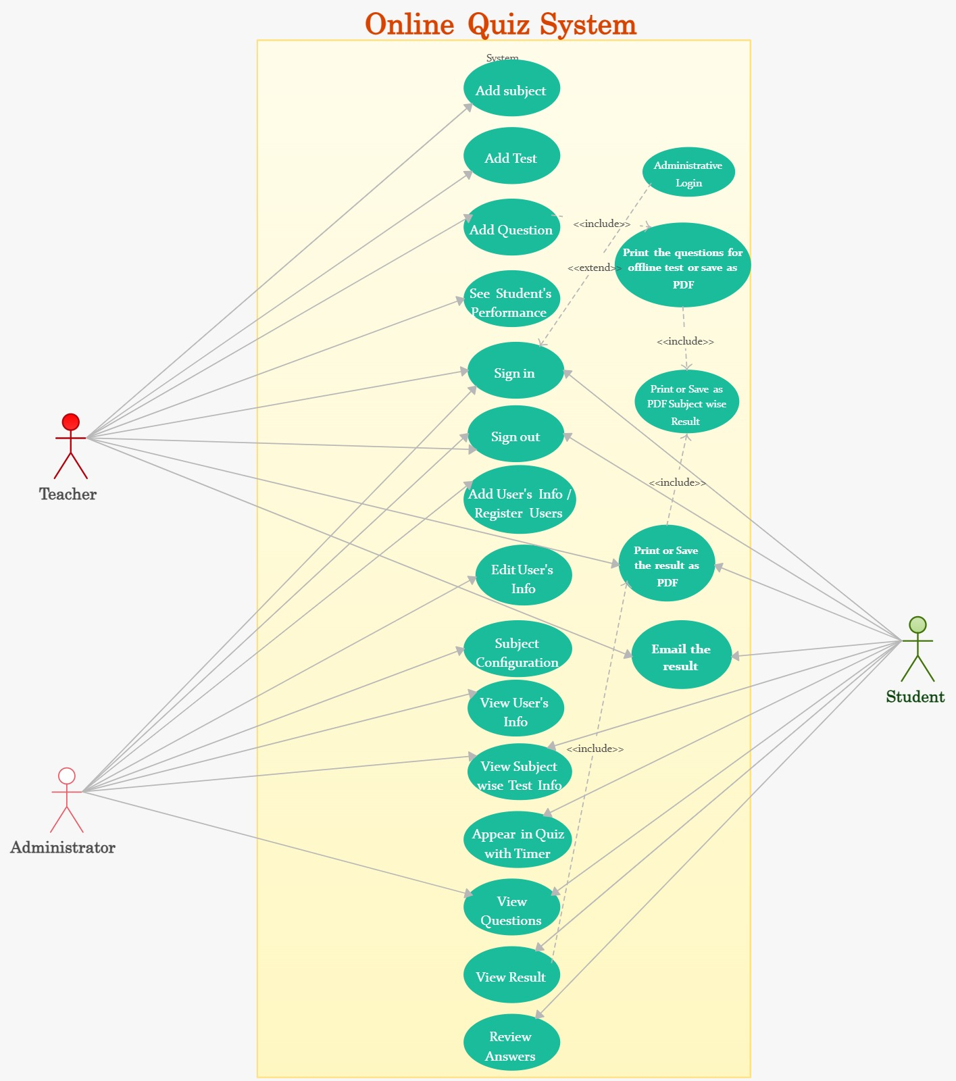

**SCREENSHOTS:**

**LINK OF THE DEPLOYED APPLICATION:**